**THAKUR POLYTECHNIC,KANDIVALI**

**DIPLOMA IN COMPUTER ENGINEERING**



**SYCO C**

**SEMESTER 4 [2023-24]**

**(GROUP NO. 31)**

**SUBJECT: MICROPROCESSOR (22415)**

**Microproject: Separate ODD and EVEN number from given array, and sort numbers in ascending or descending order.**

**COs Achieved:**

|  |  |
| --- | --- |
| **c.** | Use instructions for different addressing modes. |
| **d.** | Develop an assembly language program using assembler |

|  |  |  |
| --- | --- | --- |
| **Roll No.** | **Enrollment No.** | **Name** |
| **180** | **23151460321** | **DEEPAK RANJEET YADAV** |
| **181** | **23151460322** | **HAFIZJEE MOHAMMAD TAIYEB** |
| **182** | **23151460323** | **KAROL SAZIA SAALIM** |
| **183** | **23151460324** | **KURHADE ROHAN SURESH** |
| **184** | **23151460325** | **MISHRA VISHNUKANT ANIL** |

# Guided By: - Mr.Manish Salvi



MAHARASHTRA STATE BOARD OF TECHNICAL EDUCATION

**Certificate**

This is to certify the following group of students roll no.(**180,181,182,183,184**)of **4th** semester of Diploma in **Computer Engineering(CO)** of institute, **Thakur Polytechnic** (CODE: - 0522**)** has completed the **Micro Project : Separate ODD and EVEN Number from given array, and sort number in ascending or descending order.** satisfactorily in the Subject – Microprocessor (22415) for the Academic year 2023to 2024as prescribed in the Curriculum.

Place: Mumbai

Enrollment No.: 23151460321, 23151460322, 23151460323, 23151460324, 23151460325.

Date:

|  |  |
| --- | --- |
| **Roll No.** | **Seat No.** |
| **180** |  |
| **182** |  |
| **183** |  |
| **184** |  |
| **185** |  |

**Subject Teacher Head of the Department Principal**

**Mr.Manish Salvi Ms.Vaishali Rane Dr.S.M.Ganechari**

Seal of Institution

**ACKNOWLEDGEMENT**

We would like to express our special thanks of gratitude to our institute **Thakur Polytechnic** and our principal **Dr.S.M.Ganechari**, our head of the department **Ms.Vaishali Rane** and our subject teacher **Mr Manish Salvi** who gives us opportunity to make this micro project on: **Array - Separate ODD and EVEN number from given array, store them in separate array and sort numbers in ascending or descending order.** This has greatly helped us in expanding my cohere of knowledge. We are thankful to each other because every one of us aided to complete this project within the limited frame of time.

|  |  |  |
| --- | --- | --- |
| **Roll No.** | **Enrollment No.** | **Name** |
| **180** | **23151460321** | **DEEPAK RANJEET YADAV** |
| **181** | **23151460322** | **HAFIZJEE MOHAMMAD TAIYEB** |
| **182** | **23151460323** | **KAROL SAZIA SALIM** |
| **183** | **23151460324** | **KURHADE ROHAN KURHADE** |
| **184** | **23151460325** | **MISHRA VISHNUKANT ANIL** |

**PROPOSAL**

● **Array - Separate ODD and EVEN number from given array, store them in separate array.and sort numbers in ascending or descending order**

1. **Aim of the Micro-Project:**

Array - Separate ODD and EVEN number from given array, store them in separate array . and sort numbers in ascending or descending order

In this project we have learnt how to find whether this number is even or odd using assembly language. We stored it in different arrays.

1. **Course Outcome addressed:**

The theory, practical experiences and relevant soft skills associated with the course are to be taught and implemented, so that the student demonstrates the following industry oriented Cos associated with the above mentioned competency:

**c.** **Use instructions for different addressing modes.**

**d. Develop an assembly language program using assembler.**

1. **Proposed Methodology:** 
   * 1. Prepare Algorithm and flowchart.
     2. Write the program and get the output.
     3. Prepare a proposal and report.

1. **Action Plan:**

|  |  |  |  |  |
| --- | --- | --- | --- | --- |
| **Sr**  **No** | **Activity Details** | **Starting Date** | **Finishing Date** | **Name Of Responsible Team Members** |
| 1. | Proposal of the micro project. | 04/02/2024 | 07/02/2024 | Sazia karol,Deepak Yadav |
| 2. | Making of algorithm n flowchart as per problem definition | 07/02/2024 | 13/02/2024 | Rohan Kurhade, Mohammad Taiyeb |
| 3. | Building of code and execution. | 15/02/2024 | 19/02/2024 | All Team Members |
| 4. | Debugging and Testing | 19/03/2024 | 23/03/2024 | All Team Members |
| 5. | Making Report of the micro project | 23/02/2024 | 27/02/2024 | Rohan Kurhade, Vishnukant Mishra |

**5.Resources Used**

|  |  |  |  |
| --- | --- | --- | --- |
| **Sr.**  **No** | **Name of Resource/material** | **Specification** | **Quantity** |
| 1. | TASM 1.4 | DosBox | 1 |
| 2. | Microsoft Word | Office 365 | 1 |
| 3. | TLinker | 2.0 | 1 |
| 4. | Assembler | 3.0 | 1 |
| 5. | Debugger | Debug or TD | 1 |
| 6. | Editor | MS DOS EDIT | 1 |

• **Names of Team Members:**

|  |  |  |
| --- | --- | --- |
| **Roll No.** | **Enrollment No.** | **Name** |
| **180** | **23151460321** | **YADAV DEEEPAK RANJEET** |
| **181** | **23151460322** | **HAFIZJEE MOHAMMAD TAIYEB** |
| **182** | **23151460323** | **KAROL SAZIA SALIM** |
| **183** | **23151460324** | **KURHADE ROHAN SURESH** |
| **184** | **23151460325** | **MISHRA VISHNUKANT ANIL** |

**Signature**

**Manish Salvi**

**Report**

**1.0 Rationale**

A microprocessor is a computer processor that incorporates the functions of a central processing unit on a single integrated circuit (IC), or sometimes up to 8 integrated circuits. The microprocessor is a multipurpose, clock driven, register based, digital integrated circuit that accepts binary data as input, processes it according to instructions stored in its memory and provides results (also in binary form) as output. Microprocessors contain both combinational logic and sequential digital logic. Microprocessors operate on numbers and symbols represented in the binary number system.

# 2.0 Aims/Benefits of the Micro-Project

Array - Separate ODD and EVEN number from given array, store them in separate array . and sort numbers in ascending or descending order

In this project we have learnt that how to find whether this number is even or odd number using assembly language. We stored it in different arrays.

# 3.0 Course outcomes achieved

The theory, practical experiences and relevant soft skills associated with the course are to be taught and implemented, so that the student demonstrates the following industry oriented Cos associated with the above mentioned competency:

* Develop an assembly language program using assembler.
* Develop assembly language programs using procedures, macros and modular programming approaches.

**4.0 Literature review**

In this project we have learnt that how to find whether this number is even or odd number using assembly language. We rotated each number first to right by 1 bit .If carry is generated then the number is odd else the number is an even number. Then we stored it in different arrays.

**5.0 Actual Methodology Followed**

* Prepare micro-project proposal with requirements ● Prepare Algorithm and flowchart.
* The prepare program, debug and Test it and get the output.
* Record contents of registers memory segment(s) and flags
* Prepare micro-project Report in prescribed format with necessary conclusions and results

# 6.0 Actual resources used

|  |  |  |  |
| --- | --- | --- | --- |
| **Sr.No** | **Name of Resource/material** | **Specification** | **Quantity** |
| 1. | TASM 1.4 | DosBox | 1 |
| 2. | Microsoft Word | Office 365 | 1 |
| 3. | TLinker | 2.0 | 1 |
| 4. | Assembler | 3.0 | 1 |
| 5. | Debugger | Debug or TD | 1 |
| 6. | Editor | MS DOS EDIT | 1 |

**ALGORITHM AND FLOWCHART**

ALGORITHM:

1.Initialize the data segment.

2.Initialize counter by 5.

3.move offset of num and num1 in SI and DI registers respectively.

4.Move contents of SI to Al register and rotate Al to right by 1bit.

5.If carry is not generated then rotate left and move the no to DI.

6.If carry is generated then rotate last to get the original number.

7.Terminate the segment.

8.End.

FLOWCHART:

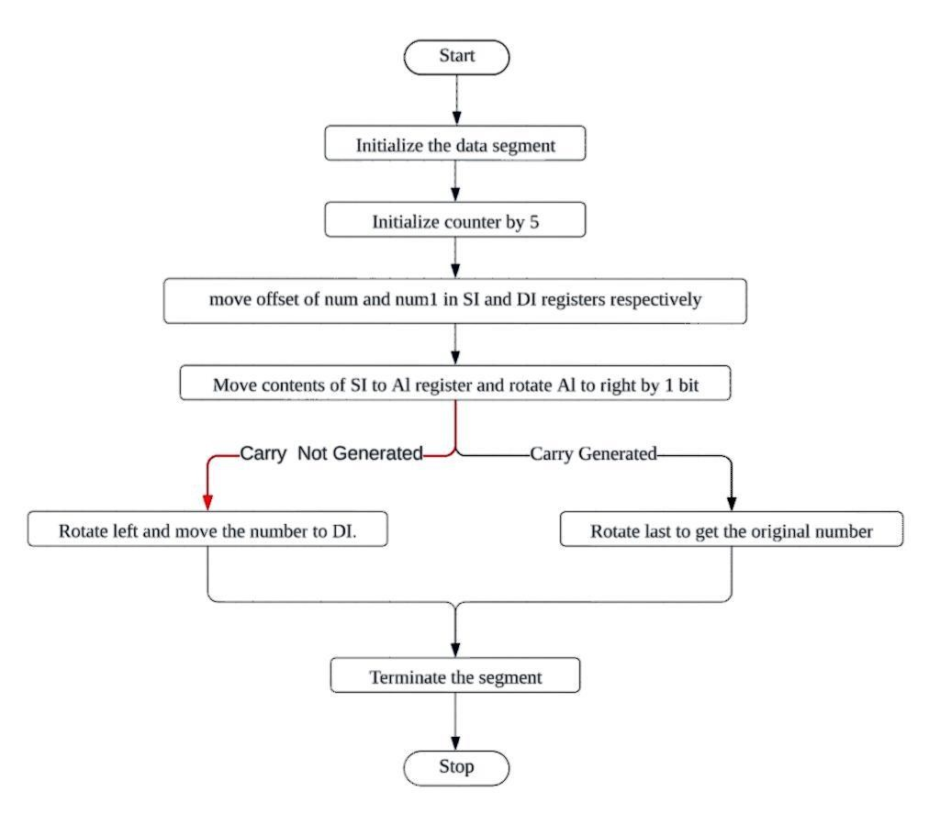

**PROGRAM CODE ( ;with comments)**

|  |  |  |  |  |
| --- | --- | --- | --- | --- |
| **Memory Address** | **OPCODE**  **(s)** | **Label:**  **(if any** | **Instruction(s)** | **;Comment** |
|  |  |  | **CODE SEGMENT** |  |
|  |  |  | **ASSUME**  **CS:CODE,DS:DATA** |  |
| **CS:0000** | **B8B048** | **START:** | **MOV AX,DATA** |  |
| **CS:0003** | **8ED8** |  | **MOV DS,AX** |  |
| **CS:0005** | **B90600** |  | **MOV CX,06H** |  |
| **CS:0008** | **BE0000** |  | **MOV SI,OFFSET NUM** |  |
| **CS:000B** | **BF1300** |  | **MOV DI,OFFSET NUM1** |  |
| **CS:000E** | **BB0B00** |  | **MOV BX,OFFSET NUM2** |  |
| **CS:0011** | **B400** |  | **MOV AH,0000H** |  |
| **CS:0013** | **EB07** |  | **JMP NEXT** |  |
| **CS:0016** | **DOCO** | **DOWN:** | **ROL AL,1** |  |
| **CS:0018** | **8807** |  | **MOV [BX],AL** |  |
| **CS:001A** | **46** |  | **INC SI** |  |
| **CS:001B** | **43** |  | **INC BX** |  |
| **CS:001C** | **8A04** | **NEXT:** | **MOV AL,[SI]** |  |
| **CS:001E** | **D0C8** |  | **ROR AL,1** |  |
| **CS:0020** | **73F4** |  | **JNC DOWN** |  |
| **CS:0022** | **DOCO** |  | **ROL AL,1** |  |
|  |  |  | **JNC DOWN** |  |
|  |  |  | **ROL AL,1** |  |
| **CS:0024** | **8805** |  | **MOV [DI],AL** |  |
| **CS:0026** | **47** |  | **INC DI** |  |
| **CS:0027** | **46** |  | **INC SI** |  |
| **CS:0028** | **E2F2** |  | **LOOP NEXT** |  |
| **CS:002A** | **B44C** |  | **MOV AH,4CH** |  |
| **CS:002C** | **CD21** |  | **INT 21H** |  |
|  |  |  | **CODE ENDS** |  |
|  |  |  | **DATA SEGMENT** |  |
|  |  |  | **NUM DB**  **21 H,44h,65h,23h,71h, 1**  **0H** |  |
| **CS:002E** | **0000** |  | **A DB 05 DUP(0)** |  |
| **CS:0030** | **214465** |  | **NUM2 DB 8 DUP(4)** |  |
| **CS:0033** | **237110** |  | **NUM1 DB 8 DUP(9)** |  |
|  |  |  | **DATA ENDS** |  |
|  |  |  | **END** |  |

CODE SEGMENT

ASSUME CS:CODE,DS:DATA

MOV AX,DATA

MOV DS,AX

MOV CX,06H

MOV SI,OFFSET NUM

MOV DI,OFFSET NUM1

MOV BX,OFFSET NUM2

MOV AH,0000H

JMP NEXT DOWN:

ROL AL,1

MOV [BX],AL

INC SI

INC BX

NEXT: MOV AL,[SI]

ROR AL,1

JNC DOWN

ROL AL,1

MOV [DI],AL

INC DI

INC SI

LOOP NEXT

MOV AH,4CH

INT 21H CODE ENDS

DATA SEGMENT

NUM DB 21H,44h,65h,23h,71h,10H

A DB 05 DUP(0)

NUM2 DB 8 DUP(4)

NUM1 DB 8 DUP(9)

DATA ENDS

END

**Output Screens:**

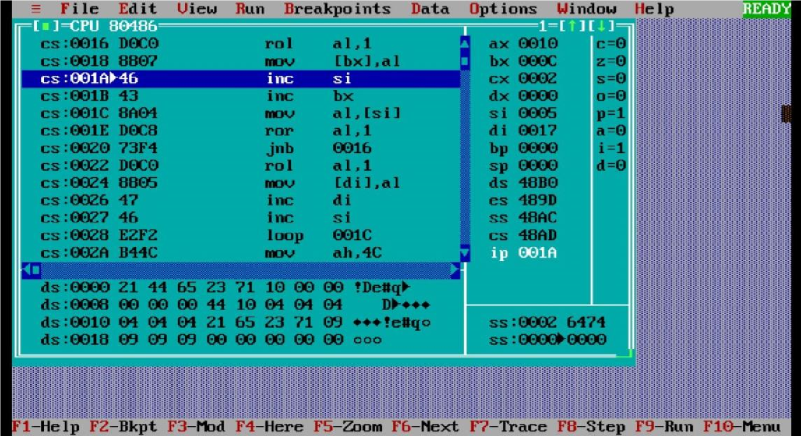

|  |  |  |  |
| --- | --- | --- | --- |
| **Registers** | | **Registers** | |
| **AX** | 0010 | C | 0 |
| **BX** | 000C | **Z** | 0 |
| **CX** | 0002 | **S** | 0 |
| **DX** | 0000 | **O** | 0 |
| **SI** | 0005 | **P** | 1 |
| **DI** | 0017 | **A** | 0 |
| **BP** | 0000 | **I** | 1 |
| **SP** | 0000 | **D** | 0 |
| **DS** | 48B0 |  |  |
| **ES** | 489D |  |  |
| **SS** | 48AC |  |  |
| **CS** | 48AD |  |  |
| **IP** | 001A |  |  |

|  |  |  |  |
| --- | --- | --- | --- |
| **MEMORY CONTENTS:** | | |  |
| **DS:0000** | 21 | **DS:000B** | 44 |
| **DS:0001** | 44 | **DS:000C** | 10 |
| **DS:0002** | 65 | **DS:000D** | 04 |
| **DS:0003** | 23 | **DS:000E** | 04 |
| **DS:0004** | 71 | **DS:000F** | 04 |
| **DS:0005** | 10 | **DS:0010** | 04 |
| **DS:0006** | 00 | **DS:0011** | 04 |
| **DS:0007** | 00 | **DS:0012** | 04 |
| **DS:0008** | 00 | **DS:0013** | 21 |
| **DS:0009** | 00 | **DS:0014** | 65 |
| **DS:000A** | 00 | **DS:0015** | 23 |

**7.0 Skills Developed / Learning outcome of the Micro project:**

Thus we learnt to separate odd and even numbers from an array and to store in different array.

**8.0 Applications of this Micro-project**

With the help of this micro-project we have designed a code that separate ODD and EVEN numbers from an array and to store in different array. and sort numbers in ascending or descending order.

In this micro project we have make algorithm and flowchart related to separate ODD and EVEN number from given array, store them in separate array. and sort numbers in ascending or descending order.

|  |  |
| --- | --- |
| **Roll Number of the Team members** | **Name of the Team Members** |
| **180** | **YADAV DEEPAK RANJEET** |
| **181** | **HAFIZJEE MOHAMMAD TAIYEB** |
| **182** | **KAROL SAZIA SALIM** |
| **183** | **KURHADE ROHAN SURESH** |
| **184** | **MISHRA VISHNUKANT ANIL** |

**Signature**

## Mr. Manish Salvi